# GITHUB INSTALLATION – Akhil

<https://www.howtoforge.com/tutorial/install-git-and-github-on-ubuntu/>

## Installing Git for Linux

1. apt-get update
2. apt-get install git

## Configuring GitHub

1. sudo git config --global user.name "user_name"
2. sudo git config --global user.email "email_id"

e.g.,

1. sudo git config --global user.name "AkhilPatwal1612"
2. sudo git config --global user.email “[patwal.akhil@yahoo.com](mailto:patwal.akhil@yahoo.com)”

## Creating a local repository

1. sudo git init Mytest.git or Mytest

If the repository is created successfully, then you will get the following line:

*Initialized empty Git repository in /home/akhil/Mytest/.git/*

1. cd Mytest.git

## 4 Creating a README file to describe the repository

1. vim README

Write anything in this file

## 5 Adding repository files to an index

1. vim testing

Write anything or your code

So, now that we have 2 files

**testing and README**

add it to the index by using the following 2 commands:

1. git add README
2. git add testing

## 6 Committing changes made to the index

1. git commit -m "some_message"

## 7 Creating a repository on GitHub

Create a repository on GitHub. Notice that the name of the repository should be the same as the repository's on the local system. In this case, it will be "Mytest". To do this login to your account on https://github.com. Then click on the "plus(+)" symbol at the top right corner of the page and select "create new repository". Fill the details as shown in the image below and click on "create repository" button.

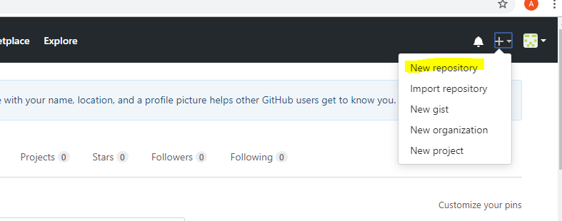

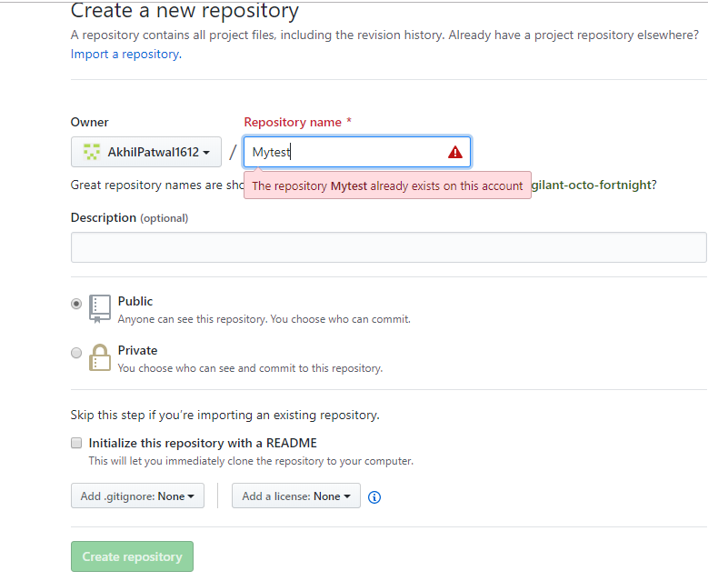

**Important Note:** Make sure you replace 'user_name' and 'Mytest' in the path with your Github username and folder before running the command!

1. cd /home/akhil/Mytest.git
2. sudo git remote add origin <https://github.com/AkhilPatwal1612/Mytest.git>

## 8 Pushing files in local repository to GitHub repository

1. git push origin master

